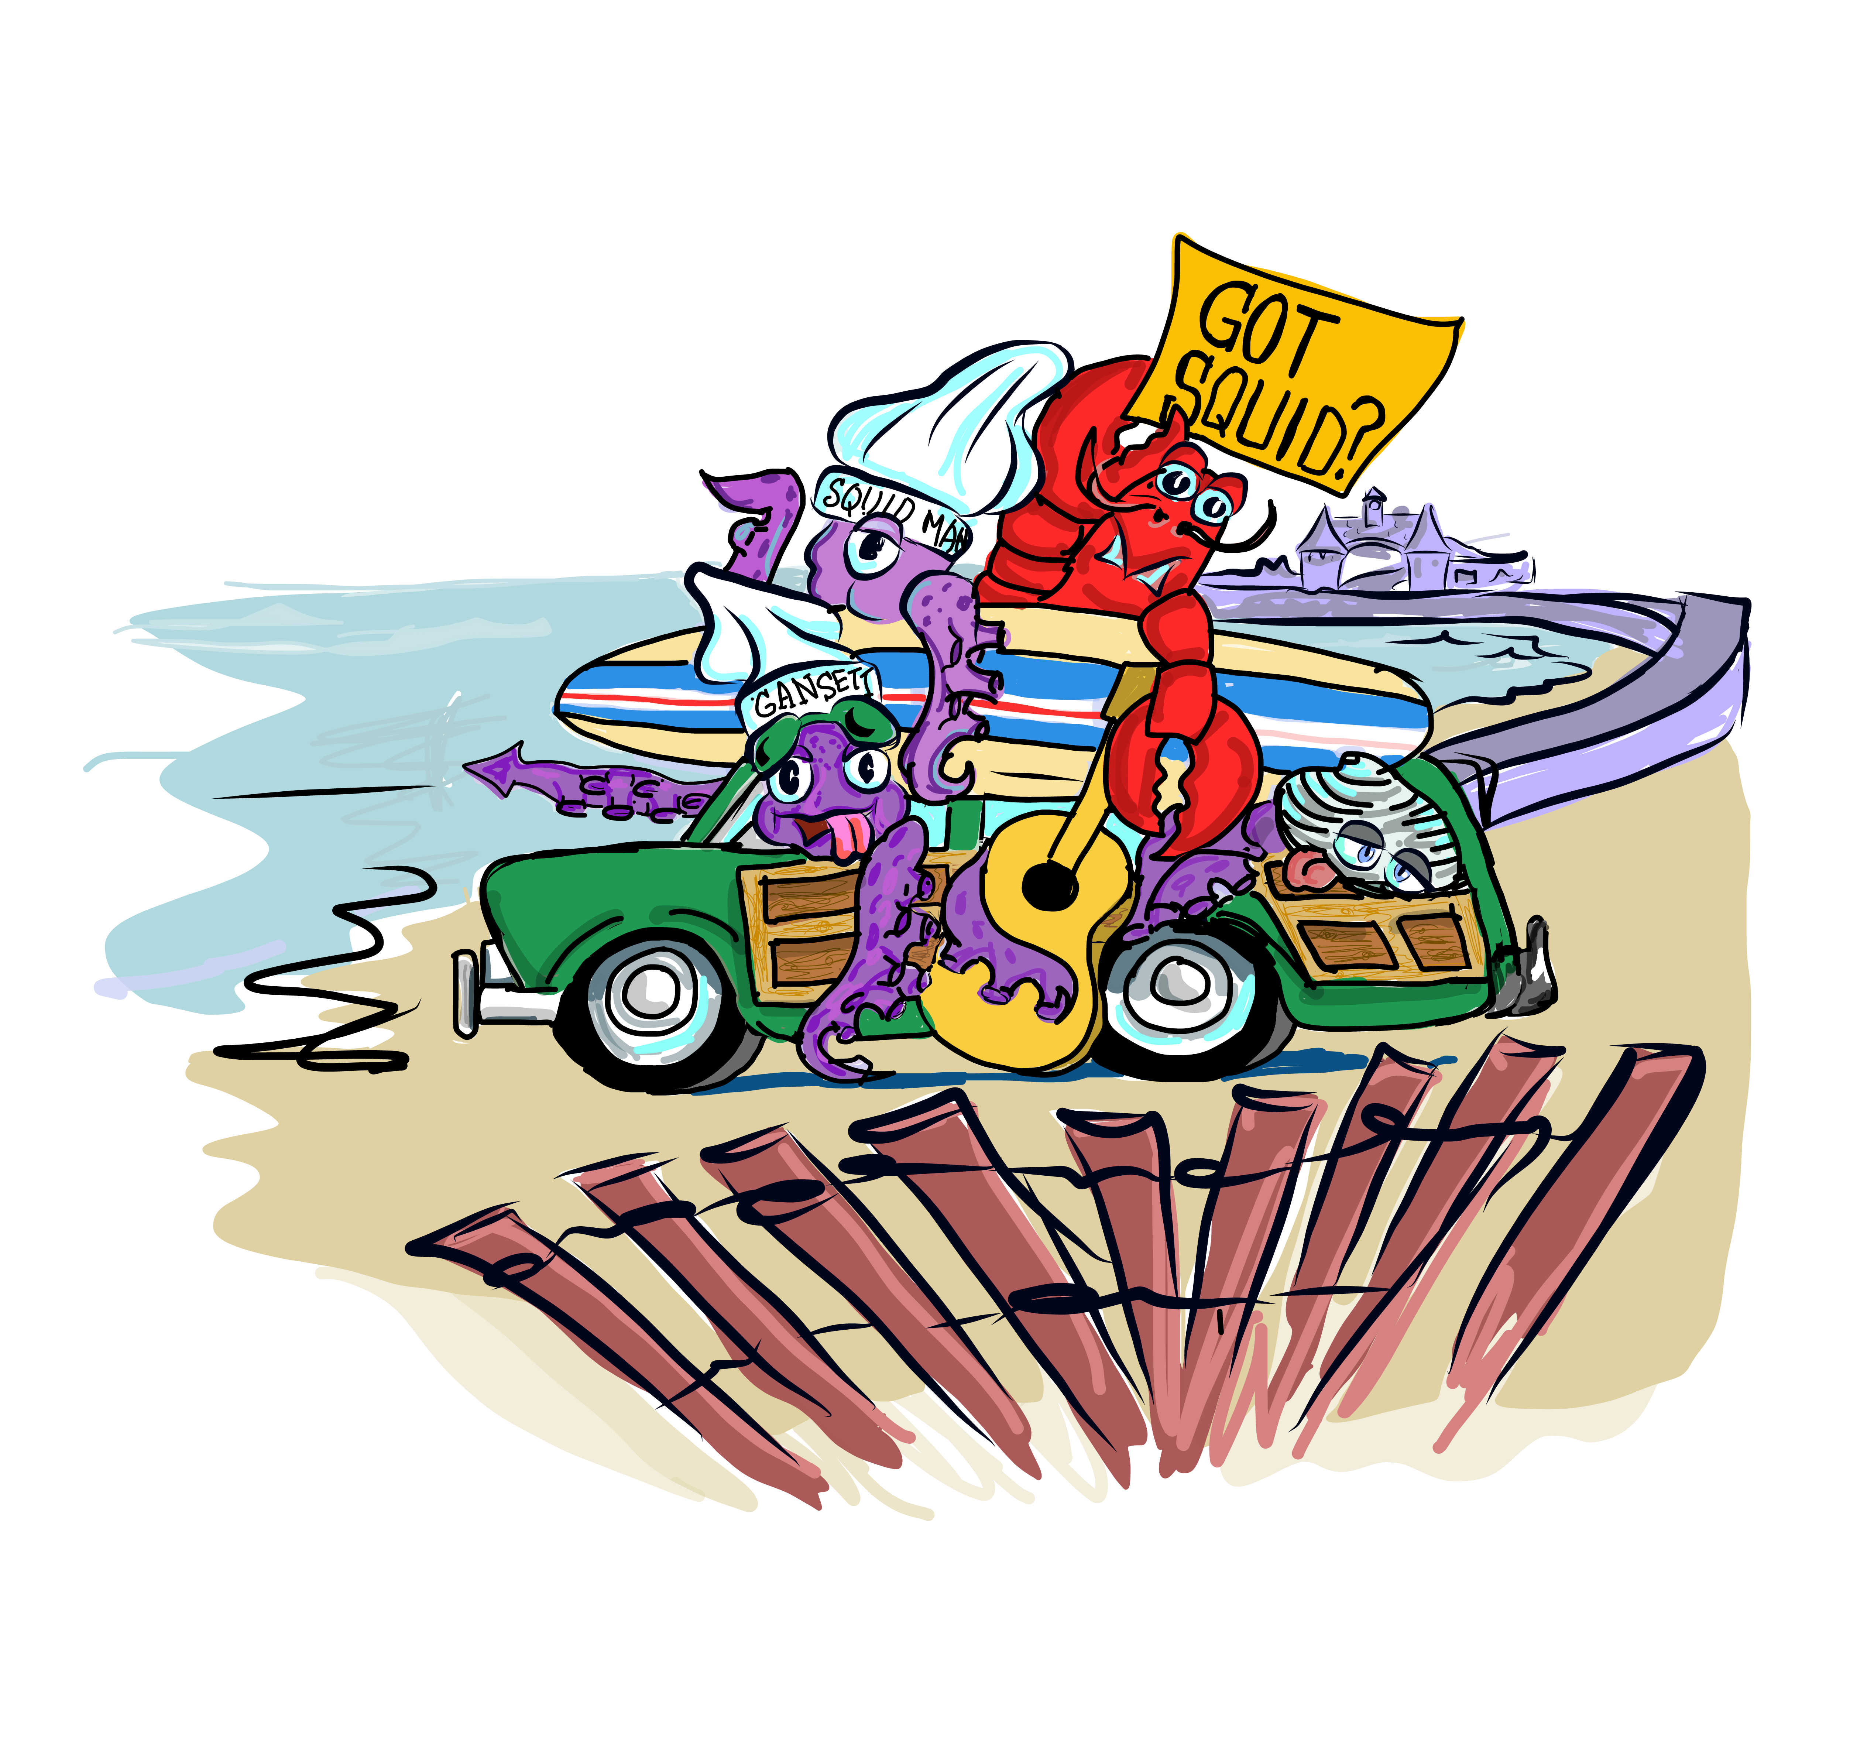
We have some BIG News from Deep!
Our Calamari Festival has now grown to be one of Narragansett’s biggest events, serving over 1,500 lbs. of calamari while drawing in thousands of people from across Rhode Island & Southern New England.
This Festival commemorates the naming Calamari as the State’s Official Appetizer In 2019. Held rain or shine, under our tent, it features a Calamari Cook-off, Live Entertainment and Good Old Fashion Fun! Patrons come year after year. It is our 7th year!
Usually the Endless Summer Celebration sponsored by the Lions Club, that features live music, food and drink along with Gansett Days (sponsored by Parks & Rec) where local attractions are featured are held the weekend after our festival so….This year we are COMBINING efforts for one BIG Weekend!
“Gansett Fest”
September 15th ,16th ,17th
Friday-Endless Summer Fest. with food trucks, live music, and beer garden 5-10pm
SaturDAY- 7th Annual RI Calamari Festival and Cook-Off, live music and beer garden- 11am-4pm
Saturday Night- Endless Summer Fest. con’t. 5-10pm
Sunday- Gansett Days …Helicopter Rides, Boon Street Tour, South County Museum
IT’S A THREE-FER!!
Your company banner will be on full display for ALL Three Days for maximum exposure!
Please consider supporting this BIG weekend event. From a marketing perspective, this increases your business visibility locally and throughout the State…and at a great value.

Choose of the following opportunities
Sold out

(1) Major Sponsor $7500
Includes: a. Company Banner size of your choosing with prime placement
b. 10 Admission Tickets
c. Your logo appears in all pre-event advertising, collateral materials and on the event website. Sizing reflects Major Sponsor
Sold out

(2) Calamari Cook-Off Sponsor $5000
Sold out
Includes: a. Company Banner size of your choosing Placement in or on tent
b. 5 Admission Tickets
c. Your logo appears in all pre-event advertising, collateral materials and on the event website. Sizing reflects Cook Off Sponsor

(3) Beer Garden Sponsor $2500
Includes: a. Company Banner near Bar (no greater than 24”X72”)
b. 3 Admission Tickets
Sold out
(4) Entertainment Sponsor $1000
Sold out
Includes: a. Company Banner (no greater than 24”X72”)
b. Placed near bands/staging

(5) Banner Sponsor $500
Includes: a. Company Banner of your choosing (no greater than 24”X72”)
b. Placed on perimeter fencing
c. Your business listed as a Hat and T-Shirt Sponsor

Don’t wait to take advantage of this opportunity to reach thousands of people!
Return your sponsor form now to secure your spot.
Many Thanks!
Peg Fradette
PS We would love to see a team from your business volunteer to work a few hours to help us on the 16th.
2023 Gansett Fest
RI Calamari Festival Sponsorship Form

Business Name: ____________________________________________

Address: __________________________________________________

Phone: ___________________________________________________

Email: ____________________________________________________

Website: ___________________________________________________

Contact: ___________________________________________________

Sponsorship level desired: ___________________________________

Amount Enclosed: ____________________________________________

DUE DATE- August 31, 2023
Please make checks out to Narragansett Chamber of Commerce
Mail to PO Box 742
Narragansett, RI 02882

THANK YOU FOR YOUR SUPPORT!!!

If you have any questions, please contact:

Peg Fradette at 783-7121 or pfradette@narragansettcoc.com

Thank you for your continued support!

Looking for more information? Visit us www.narragansettcoc.com, see pictures of past events or on Facebook at RI Calamari Fest.

